Assignment No: 12

Title:- Write a Program to Find Number of CPU Cores and CPU Manufacturer
Objectives:
• To understand how to access system-level information in Linux.
• To learn commands used for retrieving CPU details.
• To write a program/script to display CPU cores and manufacturer.

Problem Statement:-

To develop a program in Unix/Linux that retrieves and displays the number of CPU cores and the CPU manufacturer information using system commands.

Software Requirements:-
- Linux/Unix Operating System (e.g., Ubuntu)
- Terminal access
Hardware Requirements:- Any processor above Pentium 4.

Theory & Concepts:- In Unix/Linux systems, hardware information such as CPU details can be accessed using system files and commands. The operating system stores processor-related information in special files like /proc/cpuinfo.

1. CPU Information in Linux
- The file /proc/cpuinfo contains detailed information about the CPU.
- It includes processor count, vendor ID, model name, cache size, etc.

2. Number of CPU Cores
- The number of CPU cores indicates how many tasks a processor can handle simultaneously.
- It can be found using:
  - nproc command
  - Counting processors in /proc/cpuinfo

3. CPU Manufacturer
- The CPU manufacturer (vendor) can be identified using:
  - vendor_id field in /proc/cpuinfo
- Common manufacturers include Intel and AMD.

4. Commands Used
- cat → Displays file content
- grep → Searches specific patterns
- nproc → Shows number of processing units

5. Advantages
- Helps in system monitoring and performance analysis
- Useful for system administrators and developers
- Enables better resource management

Algorithm:
- Start
- Open terminal
- Use command to find number of CPU cores
- Use command to find CPU manufacturer
- Display the results
- Stop

Program / Implementation:

Method 1: Using Commands
echo "Number of CPU cores:"
nproc
echo "CPU Manufacturer:"
grep "vendor_id" /proc/cpuinfo | uniq

Sample output:
Example:
Number of CPU cores:
8
CPU Manufacturer:
vendor_id : GenuineIntel
If AMD processor:
Number of CPU cores:
8
CPU Manufacturer:
vendor_id : AuthenticAMD

Method 2: Using Shell Script
#!/bin/bash
echo "CPU Information"
echo "Number of CPU cores:"
cores=$(nproc)
echo $cores
echo "CPU Manufacturer:"
manufacturer=$(grep "vendor_id" /proc/cpuinfo | uniq | awk '{print $3}')
echo $manufacturer

Output:
CPU Information
Number of CPU cores:
8
CPU Manufacturer:
GenuineIntel

Flowchart:-

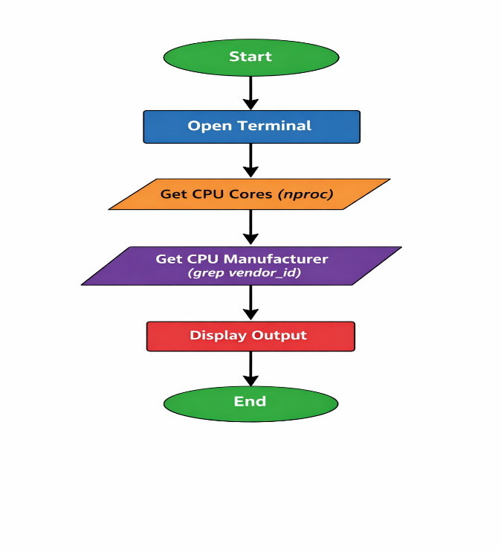

Conclusion:-
This experiment demonstrates how Linux provides easy access to system hardware information through commands and system files like /proc/cpuinfo.

Questions:
• What is /proc/cpuinfo?
• What does nproc command do?
• What is the difference between CPU cores and threads?
• How does grep work?
• Can you get CPU information using GUI tools?

Perform ance, results, & interpre tation of results(5 M) | Background Knowledge/ Understanding (2M) | Performance beyond defined scope- Self learning, innovation/ supplementar y/ extra / optimized performance/ results (1M) | Documentat ion & presentation (1M) | Timely completion & submission (1M) | Total (10)

Date of Performance: Date of Assessment: Signature of Faculty:

Explanation
(No Need to Write):

Line 1
#!/bin/bash
Explanation:
- This is called a shebang line.
- It tells the system to execute the script using the Bash shell.
- /bin/bash is the path of the Bash interpreter.

Line 2
echo "CPU Information"
Explanation:
- echo command prints text on the terminal.
- This prints the heading CPU Information.
Output:
CPU Information

Line 3
echo "Number of CPU cores:"
Explanation:
- Prints the label for CPU cores.
Output:
Number of CPU cores:

Line 4
cores=$(nproc)
Explanation:
- nproc command returns the number of CPU processing units.
- $( ) is command substitution (stores command output in variable).
- The output of nproc is stored in variable cores.
Example:
cores=8

Line 5
echo $cores
Explanation:
- Prints the value stored in variable cores.
- $ is used to access variable value.
Output example:
8

Line 6
echo "CPU Manufacturer:"
Explanation:
- Prints label for CPU manufacturer.
Output:
CPU Manufacturer:

Line 7
manufacturer=$(grep "vendor_id" /proc/cpuinfo | uniq | awk '{print $3}')
Explanation (step by step):

Part 1
grep "vendor_id" /proc/cpuinfo
- Searches CPU vendor information.
- /proc/cpuinfo contains CPU details.
- Example output:
vendor_id : GenuineIntel
vendor_id : GenuineIntel

Part 2
uniq
- Removes duplicate lines.
- Result:
vendor_id : GenuineIntel

Part 3
awk '{print $3}'
- awk extracts specific columns.
- $3 means 3rd column.
- Output:
GenuineIntel

Final Result
Stores:
manufacturer=GenuineIntel

Line 8
echo $manufacturer
Explanation:
- Prints CPU manufacturer stored in variable.
Output:
GenuineIntel

Final Working Flow of Script (No Need to write)
Script performs:
- Prints CPU heading
- Gets number of CPU cores
- Displays cores
- Gets CPU vendor name
- Displays vendor

Difference from your previous program (No Need to write)

Method 2 program printed only:
GenuineIntel
Method 1 program prints:
vendor_id : GenuineIntel
Because awk is not used to extract column.

Short Viva Explanation (if asked in exam) (No Need to write)

What is nproc?
→ Command to display number of CPU cores.
What is /proc/cpuinfo?
→ File containing CPU hardware information.
What is grep?
→ Command to search text.
What is awk?
→ Text processing tool used to extract columns.
What is command substitution?
→ Using command output inside variable using $().

